**TITLE OF LAB: (CURRENT VOLTAGE CHARACTERISTICS FOR DIODE)**

**Lab No. #02**



**Spring 2022**

**CSE-206L Electronic Circuits Lab**

Submitted by

**Safi Ullah Khan : 20PWCSE1943**

Class Section: **B**

“On my honor, as student of University of Engineering and Technology, I have neither given nor received unauthorized assistance on this academic work.”

Student Signature: ______________

Submitted to:

**Engr. Abdullah Hamid**

(Monday, June 19th, 2022)

**Department of Computer Systems Engineering**

**University of Engineering and Technology, Peshawar**

**Objectives:**

* Study the working of diode.
* To know about the forward and reverse biased.
* To get hands-on experience of working with diodes in Proetus.

I first build the following circuit for silicon’s forward biased region.

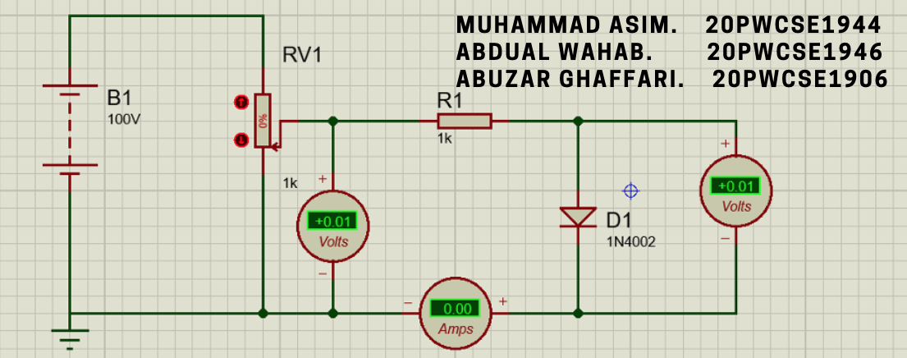

Figure 1: Forward bias configuration for silicon diode

I went on to increase the voltage and noted the corresponding current. A scattered graph of Current vs Voltage is plotted bellow.

Figure 2: IV graph for silicon diode for voltage >= 0.

I then reversed the direction of diode and, although I could instead have reversed the direction of battery as well, but I found it more convenient to change the direction of diode since changing battery’s direction would have also required changing polarity of the two-volt meters and the ammeter.

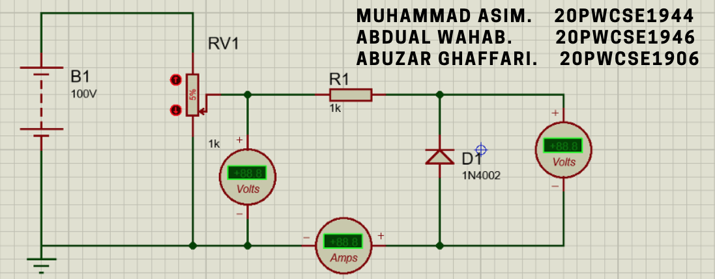

Figure 3: Reverse biased configuration for silicon diode.

As I went on to increase the supply voltage by tapping the upper arrow of potentiometer, I saw that the current did not increase. To the point that I reached the maximum 100 V I could get from the battery.

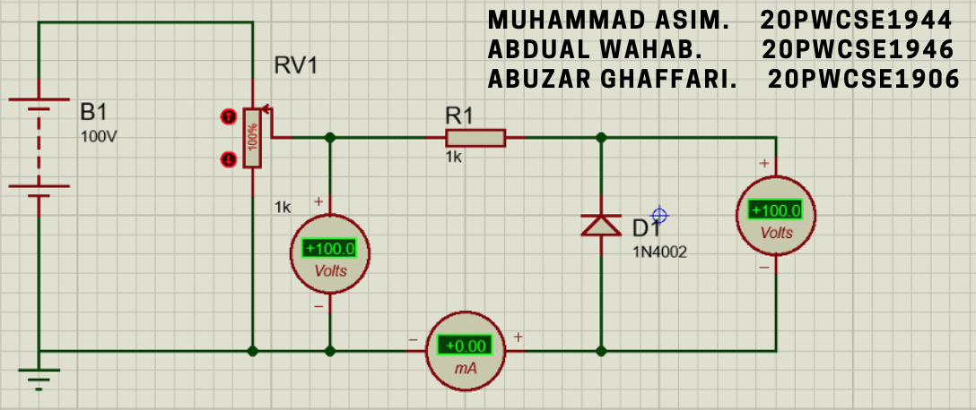

Figure 4: Silicon diode reverse bias configuration.

This was the maximum I could get from the battery. I then changed battery’s properties and set its voltage to 200.

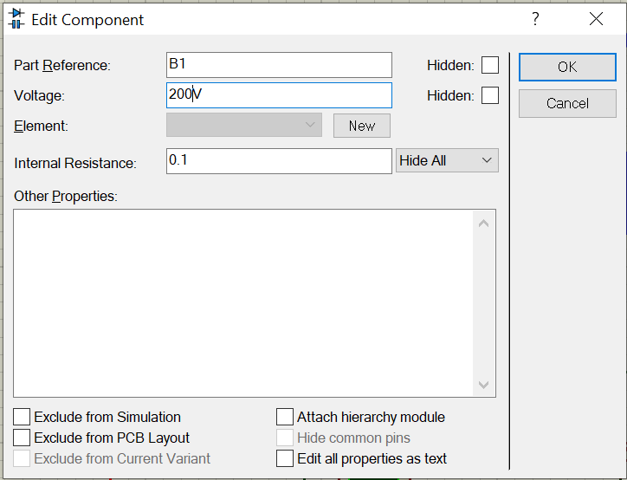

Figure 5: Battery's voltage changed to 200V

After changing voltage, now as I went on to increase the supply voltage, the voltage across the diode remained 100 and the current kept increasing which led me to the conclusion that the breakdown voltage for silicon diode, or at least for the 1N4002 that I used, is 100V. It just so happened that I had previously set the battery’s voltage exactly equal to the breakdown voltage.

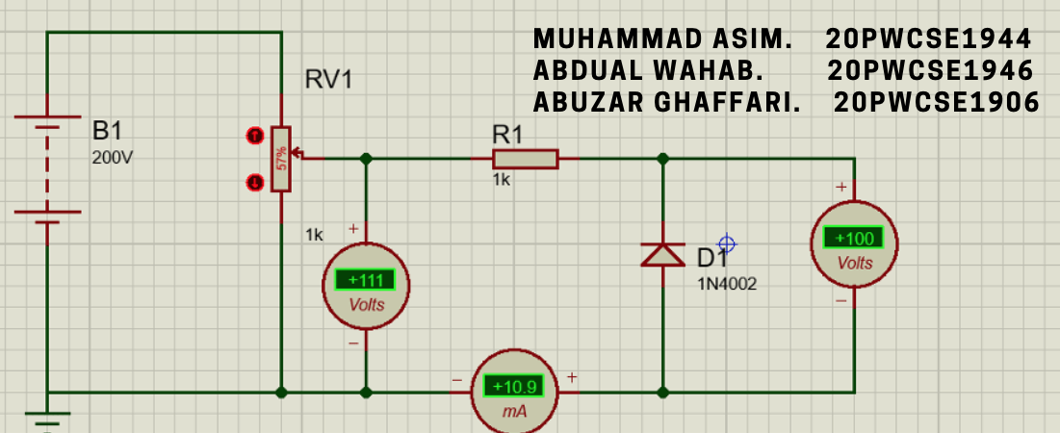

Figure 6: While the supply voltage is 111V the voltage across diode is a constant 100

This brings us to the next problem that is the issue of plotting asymptotes. The current remained zero until 100 volts and then increase rapidly while the voltage remained a constant 100V. This means the graph will have a very sharp, almost of 90°, edge. This is obviously not the graph we are quite familiar with when it comes to breakdown region. But Proteus is simulation software that basically calculates according to theoretical equations so it’s not surprising to get sharp edge from Proteus values.

Figure 7: IV graph for silicon diode for voltage < 0 volts

I then moved to doing the same with germanium diode.

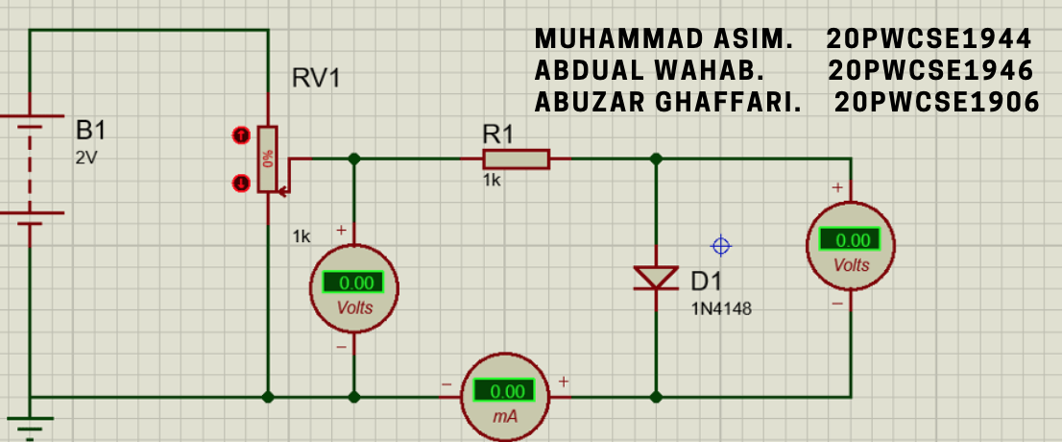

Figure 8: Forward bias configuration for Germanium diode

Since I knew Germanium diode has a lower threshold voltage, I set the battery to 2V so that each step would provide me a more precise value.

Figure 9: IV graph for forward bias configuration of Germanium diode

As with silicon diode, I changed the direction of Germanium diode too.

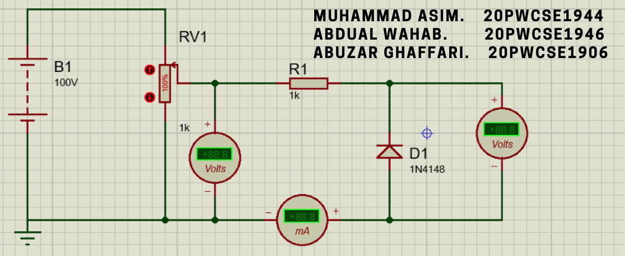

Figure 10: Reverse bias configuration for Germanium diode.

The current remained 0 until and on 75 V but then it drastically increased.

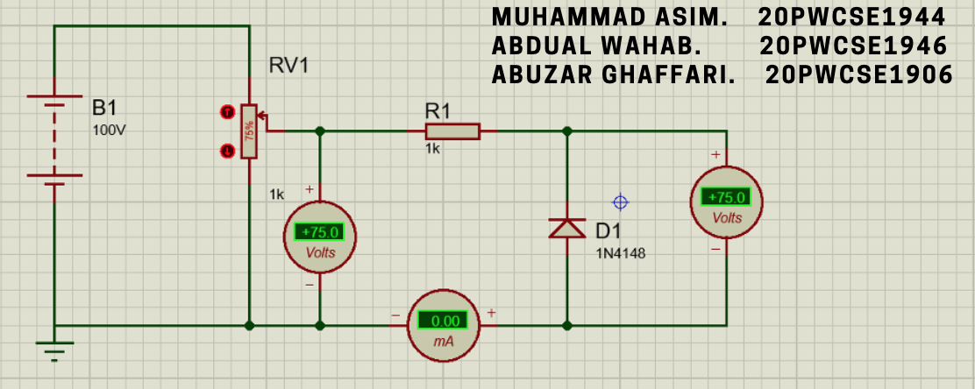

Figure 11: Germanium current was zero at -75 V

What I noticed was that unlike silicon diode where the voltage across the diode remained 100V, or rather I should say -100V, no matter how much the supply voltage increased, the voltage across germanium diode did increase to 75.6V which lead to me to conclusion that the breakdown region in Germanium diode occurs at -75 V to round about -75.6 V.

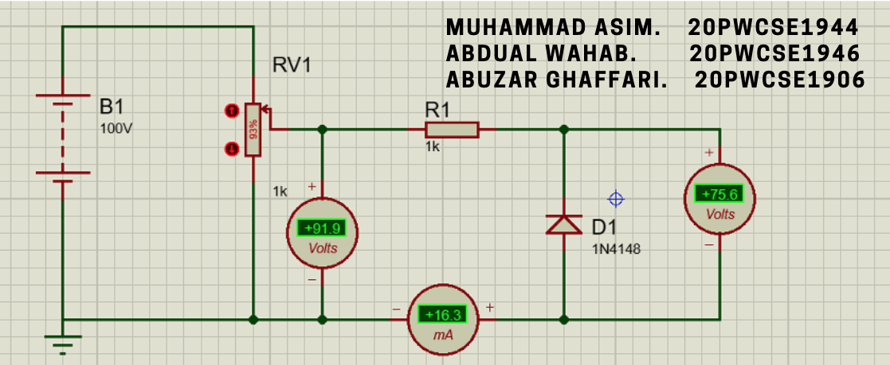

Figure 12: Voltage 75.6 and current 16.3

Figure 13: IV graph for Germanium diode for voltage < 0

**---------------------------------THE END-------------------------------**